Student “Caught-Ya” Menu

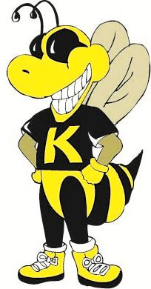

5 Caught–Ya’s
Lunch with a Friend

10 Caught-Ya’s
HW/Assignment Pass

20 Caught-Ya’s
*Lunch w/ Mr. Jakana

25 Caught-Ya’s
Kimberly T-Shirt

35 Caught-Ya’s
Name on the Marquee

Lunch with Mr. Jakana
Students who earn 20 “Caught-Ya’s” can eat lunch with Mr. Shivers. Students may combine caught-ya’s in order to eat as a group but each student in the group must have at least five caught-ya’s. The group will have a picnic with Mr. Jakana and should turn in caught-ya’s to him as their ticket to lunch. Advance notice is required so that arrangements for a sack lunch from the cafeteria can be made.

Weekly Drawings
Students may turn “Caught-Ya’s” in for a drawing at the end of each week. One student from each grade will be drawn and students will be allowed to choose prizes from Mr. Jakana’s treasure box. Students may turn tickets in at any time in the media center.

Top Cats Celebration
A party will occur at the end of each nine weeks for students who have had no N’s or U’s on the choice card. Teachers should keep up with the students in his/her homeroom that will not be able to attend. The party date should be set in advance and announced weekly on the morning announcements. Have art students or a student club make posters for the event.

